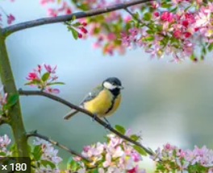
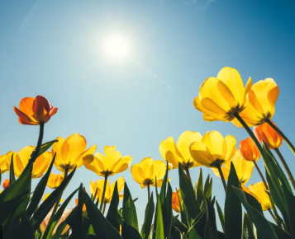

This week is our Spring / Easter themed week.
Here are some spring themed ideas to get you started!
Please note, with any outdoor activities, please follow government guidelines and observe social distancing rules.

Picking flowers outside to create a bouquet.
Life cycle of a plant.
Life cycle of lambs/sheep.
Nature walk/scavenger hunt.
Senses walk.
Nature collage - make pictures out things you’ve found outside.
Leaf/flower rubbings with crayons.
Write a descriptive paragraph about a Spring scene, what could you see, smell and feel?
Choose an animal and draw its life cycle.
Go outside and see how many signs of spring you can see.

Most of all – have fun!

